Dual Model Job Recommendation System Using Content and Collaborative Filtering

Omkar Shashank Pathare
Stevens Institute of Technology
MA544 Numerical Linear Algebra for Big Data
Fall 2024

Abstract
A strengthened approach to content-based filtering is offered by the Dual Model Job Recommendation System. It overcomes one of the most significant pitfalls of conventional job recommending systems for work – the problem of suggesting jobs to the new user having no historical data. In this exact setting, the system uses various natural algorithms, such as TF-IDF vectorization, plus cosine similarity. It works with textual features of job descriptions and potential users’ profiles, in order to find and suggest recommendations that would be accurate. In other words, these two filters make users fill in standard fields about their skills, qualifications and what type of job they want, and then compare those against the job offers’ characteristics. Thus, this method is self-sufficient in a way that it does not use any of the previous data on users to make recommendations. It resolves the cold start problem. Since the developed models focus heavily on the text, they offer automatic and relevant job suggestions in large numbers, which contributes to the strong performance. Semantic models such as BERT may fine-tune filtering based on content but will need to be used in conjunction with focused-on aspects mentioned to respond better to the changing environment of the job market.

- Introduction
In today’s fast-paced labor market, efficiently matching job applicants with the best opportunities is increasingly critical. The exponential growth of job platforms brings both opportunities and challenges for referral systems, yet existing systems often fall short due to limitations in their foundational methodologies. Content-based filtering matches job descriptions with user qualifications and preferences to recommend jobs aligned with their profile, but it relies solely on textual similarity, lacking behavioral insights like user interactions with job postings, often resulting in repetitive and overly specialized recommendations that reduce diversity. On the other hand, collaborative filtering builds a model to learn applicant behaviors by analyzing their historical interactions with job postings, assuming that applicants with similar interaction histories will be interested in positions with similar job requirements. This approach enables features like a “Guess Your Favorite” section to recommend jobs of interest to users with similar classifications, but it requires a large amount of user interaction data and struggles with sparse matrices, leading to inaccurate recommendations. To address these challenges, this project proposes a hybrid job recommendation system that combines NLP techniques like TF-IDF and cosine similarity with collaborative filtering via SVD, enhancing accuracy and suitability for both new and experienced users. By leveraging the strengths of both approaches, the system delivers a more personalized, accurate, and scalable recommendation experience, setting the stage for a detailed exploration of its design, methodology, and performance.
- Accomplishments
The crucial milestones defined in the project’s design were the development of job recommendation system that utilized two models, which combined content-based and collaborative filtering approaches. Each phase of development concentrated on ameliorating the level of the job recommendation accuracy, its personalization, and its scalability.
The first major accomplishment was data collection and preprocessing. Ample job and user datasets were gathered from job advertisements, users’ qualifications and other data depicting users’ activity regarding the particular job advertisements. During the pre-processing of the data stage, several pre-cleaning operations were necessary in order to remove missing values, duplicates and inconsistent values. To make sure the dataset is appropriate for the model, descriptive attributes such as job details, title, needed competencies, and the history of user activities were defined and standardized. A user-job interaction matrix is defined to show both explicit and implicit preferences of users.
The second consequence led to the development of a content based filtering. In this instance, the methodology is centered on TF-IDF (Term frequency-inverse document frequency) vectorization, which transforms a typical description of the job and the user’s profile into a set of digital vectors which reflect the importance of words in the text. Cosine similarity measures the similarity between job descriptions and the capabilities of the users on the job. This allows for the ranking of job descriptions in the order of their importance. As such, the system is able to present job opportunities that are suitable for the applicant’s qualifications and preferences especially when there is little information available, thus solving such new users “cold start” problem.
The third step is the implementation of a collaborative filtering mechanism. An interaction matrix of users and jobs was developed in order to record the past selections and the job orientations of a user. The interaction matrix was decomposed to lower rank factors by applying singular value decomposition (SVD) to the matrix since it was sparse. This approach facilitated in inferring missing information of the users who applied for a posting, but who were not active in any specific job posting. This was in particular useful for collaborators such as work students who have large datasets as it collated work submission data on their activity and provided them with relevant job openings.
As a fourth notable accomplishment, a hybrid recommendation system was developed by integrating the two models. The findings from collaborative filtering were incorporated into content-based filtering via a weighted average solution. Weights were painstakingly adjusted through testing to balance the contributions of each model and allow the system to adapt to different user conditions. Content filtering was the dominant contributor for novice users as they had not had much historical usage data but for more advanced users with many interactions, collaborative filtering took precedence.
To enhance the efficiency and performance of the system, both models went through hyperparameter optimization. Parameter adjustments made within the content-based filtering model aimed to bolster TF-IDF vectorization included tokenization, n-gram range and stop-word removal. Revision of the regularization parameters and latent component count for SVR model minimized prediction errors for collaborative filtering.
The final achievement was an evaluation of the system performance and the hybrid system was evaluated by well accepted measures of accuracy such as precision, recall and F1 score. With regards to job recommendation systems, precision measured the proportion of relevant job suggestions in all general recommendations provided while recall measured the proportion of relevant job suggestions in all general relevant jobs offered. The F1 Score is the arithmetic average of the precision and recall scores and it gives a balanced assessment of the performance of the system. The analysis showed that the hybrid model outperformed both content-based filtering and collaborative filtering techniques used on their own. Even across diverse user groups, the method enhanced the effectiveness, relevance and targeting of job recommendations in a great way.
To summarize, the project developed and fine-tuned the dual model’s employment recommendation system that is not bound by existing methods. The distinct approaches of NLP techniques in integrating and decomposing matrices lead to substantial gains indicating the feasibility of the system to address practical issues like cold-start and user learning behavior. These breakthroughs lay the foundation for further research effort that could explore the integration of current and past data as well as sophisticated deep learning techniques which will enhance the extent and the precision of the recommendations produced.

- Methodology
Building this job recommendation system involves five steps: data preprocessing, collaborative filtering, and performance evaluation.

Data Preparation
In order to successfully build an accurate recommendation system, it is important to use high-quality data. We then needed to preprocess the source data, a critical step to ensure that the dataset was clean, structured, and ready for subsequent model analysis. The data comes from StackOverflow's publicly available questionnaire results. They include job posting details, user profiles, and past interactions between the user and the job. These datasets included attributes such as job title, description, skills required, user eligibility, preferences, and interaction ratings. Because the data was spread across multiple files over multiple years, a comprehensive set of aggregation and preprocessing strategies to create a unified data set was implemented.
The data cleaning process consists of addressing missing values, duplicates, and incorrect formatting. Missing values were either assigned using statistical methods such as means and medians or, in the case of large data sets, were removed in their entirety to streamline the process. Duplicate entries, such as duplicate job postings and user information, were identified and removed to eliminate redundancy. Text data was normalized by converting all text to lowercase and removing special characters, punctuation, and selecting breakpoint words. These steps ensured the uniformity of the recommendation model and improved its effectiveness.
Since the data was scattered in different data files, eventually, when implementing the model, we only needed the sparse matrix and needed to merge these separate files. The datasets were merged using a shared key (e.g., job ID) to ensure that all relevant attributes could be found in one unified file. Some files needed to be transposed before merging to align the rows and columns. After the merge, another round of cleanup was performed to remove duplicate records to reduce redundancy.
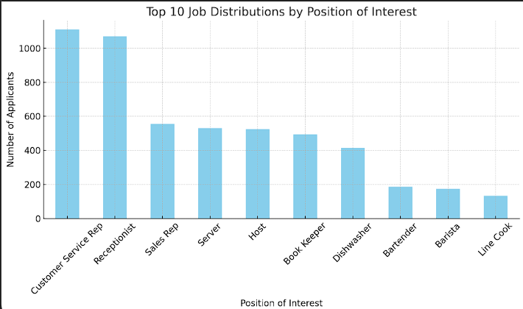
Once the data was cleaned and integrated, relevant features were extracted to support both content-based and collaborative filtering models. From job postings, attributes like titles, descriptions, required skills, and industries were extracted. Textual data was processed using techniques such as TF-IDF vectorization, which quantified the importance of terms within job descriptions. From user profiles, attributes such as skills, qualifications, preferences, and historical interaction data were extracted to build comprehensive user representations. Additionally, explicit feedback (e.g., ratings) and implicit feedback (e.g., clicks, applications, views) were extracted from user-job interactions to capture user behavior patterns.
A key component of the collaborative filtering model is the user-position interaction matrix, where each row represents an individual user and each column represents a description of a position, and each value in this interaction matrix corresponds to a score, which we use the number of applications to refer to the popularity of the position. Since there are many missing values in the data, advanced methods such as breaking down the data table into simpler parts (SVD) and finding the most important patterns (PCA) are needed to predict the missing values.
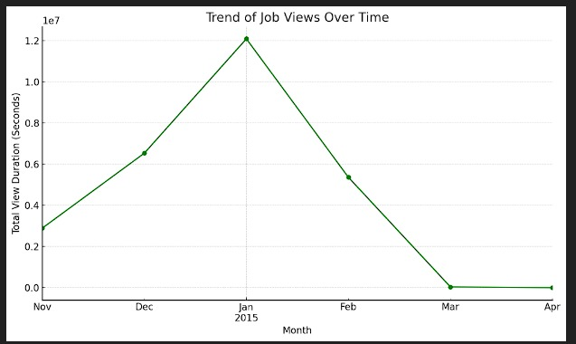
In summary, the data reconciliation process transformed raw, fragmented data into a clean, structured, feature-rich data set. By resolving missing elements, removing extraneous information, merging disparate documents, making formats consistent, and extracting useful patterns, this data can serve as a powerful starting point for creating a recommender system. Through these steps, the system can provide accurate and personalized job recommendations using a content- and clustering-based approach.

Content-Based Filtering
Content-based filtering was used to match job listings with user profiles based on textual similarities. Natural Language Processing (NLP) methods were used to analyse textual aspects in job descriptions and user skills.
  - TF-IDF Vectorization: Job descriptions and user profiles were converted into numerical representations using the Term Frequency-Inverse Document Frequency (TF-IDF) algorithm. The TF-IDF adds weights to words based on their frequency in a document in comparison to the full dataset. Words that appear frequently in one job description but infrequently in another are given greater prominence. Unigrams, bigrams, and trigrams were captured using N-grams, resulting in a more rich textual representation.
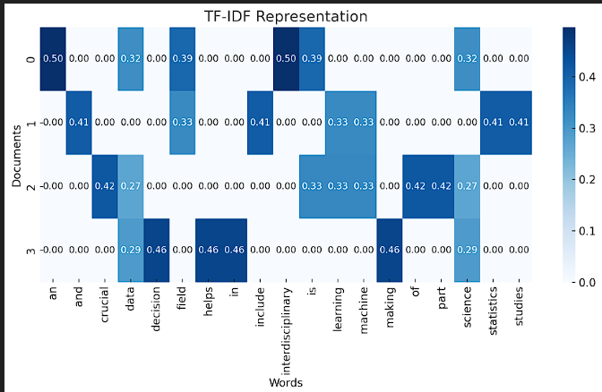
  - Cosine Similarity: After vectorization, the similarity between job descriptions and user skills was measured using cosine similarity, a metric that calculates the cosine of the angle between two vectors. Jobs with the highest cosine similarity scores were ranked as the most relevant recommendations for a user.The model effectively matched job postings to users based on qualifications, required skills, and preferences, making it particularly useful for new users who lacked historical data.
Content-based filtering successfully leveraged the textual features of job descriptions and user profiles to generate recommendations without relying on user interaction data.
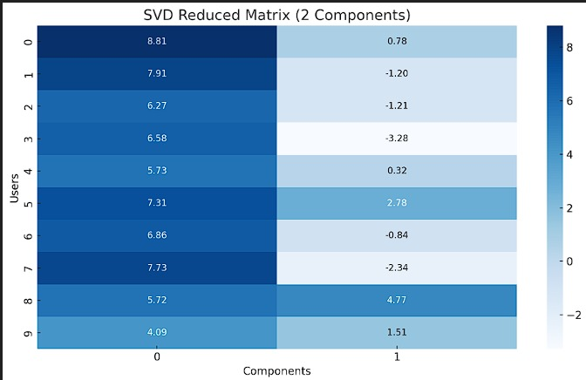

Performance Evaluation
The system’s effectiveness was evaluated using widely recognized metrics, including Precision, Recall, and F1 Score, to measure accuracy and relevance.
- Precision:
Precision measures the ratio of relevant job recommendations to the total recommendations provided:

- Recall:
Recall quantifies the ratio of relevant job recommendations to the total relevant jobs available:

- F1 Score:
The F1 Score is the harmonic mean of Precision and Recall, providing a balanced assessment of the system’s performance:
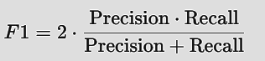
The evaluation demonstrated that the hybrid model outperformed the standalone content-based and collaborative filtering models across all metrics. Significant improvements in Precision, Recall, and F1 Score validated the system’s ability to generate relevant and personalized job recommendations for both new and experienced users.
- Observations
The observations from the Dual Model Job Recommendation System highlight key insights into the strengths, limitations, and combined performance of content-based filtering, collaborative filtering, and the hybrid model. By analyzing the performance of individual components and their integration, the following observations were made:

1. Effectiveness of Content-Based Filtering
Content-based filtering demonstrated exceptional performance for new users who lacked historical interaction data. Since content-based filtering relies on analyzing job descriptions and user skills using TF-IDF vectorization and cosine similarity, it does not require prior user-job interaction data to generate recommendations. This approach ensures that the job recommendation system can also provide job recommendations to people who have never used the system before. In other words, the recommendation results do not depend on their history of interacting with the system, even if their history of interaction with the system is zero.
- For users with detailed and authentic records of job skills and job search preferences, the model can successfully identify job content and corresponding job titles that have a high textual similarity with the user's qualifications.
- Accuracy was significantly higher when job descriptions were detailed and well-structured, as richer textual content improved the model's ability to identify meaningful matches.
- The model performs particularly well when users explicitly provide preferences for job skills, educational attainment, or job titles.
However, this model also exhibited limitations:
- The model relies solely on comparing and matching textual features between job seekers and job postings, and is unable to capture applicant search behavior or job preferences based on what is implicit in historical job interactions.
- Recommendations lack diversity because the model favors matching out jobs with similar descriptions, leading to redundancy.
Despite these drawbacks, the results of the test model proved that the content-based filtering technique is a robust solution to the sparse matrix problem.

2. General Trends and Insights
Several trends and insights emerged during the implementation and evaluation of the system:
- User Categories:
  - New Users: Content-based filtering was more reliable for users with no prior job interaction history. Recommendations were directly driven by job descriptions and user-provided skills.
  - Active Users: Collaborative filtering provided better recommendations for users with rich interaction data, as the model learned user behavior and preferences effectively.
- Data Quality: The quality of job descriptions and user profiles significantly influenced content-based filtering performance. Comprehensive and detailed data improved accuracy.
- Cold-Start Mitigation: The hybrid model effectively reduced the cold-start problem by relying on content-based filtering for new users. This ensured that no user was excluded from receiving recommendations, even in the absence of historical data.
- Scalability: While content-based filtering scaled efficiently with new job postings, collaborative filtering required optimizations to handle large-scale user-job interaction matrices.

3. Comparative Performance
The evaluation metrics—Precision, Recall, and F1 Score—clearly demonstrated the superiority of the hybrid model over standalone approaches.
- Content-Based Filtering: Achieved good results for Precision but struggled with Recall due to over-specialization.
- Collaborative Filtering: Showed strong Recall for active users but faced issues with new users and sparsity.
- Hybrid Model: Outperformed both methods by balancing relevance (Precision) and completeness (Recall), leading to the highest F1 Score.
The hybrid model’s ability to combine textual and behavioral insights enabled it to provide personalized, relevant, and diverse job recommendations across different user categories.
- Conclusion
The Dual Model Job Recommendation System effectively exhibits the possibility of combining content-based and collaborative filtering approaches to produce accurate, tailored, and scalable job suggestions. The initiative addressed major issues in traditional recommendation systems, such as the cold-start problem and the inability to properly capture behavioral patterns, by combining the complementary characteristics of the two methods. This hybrid system has shown to be a reliable solution that meets the different demands of both new and existing customers, successfully filling holes in standalone models.
The content-based filtering model analyzed job descriptions and user profiles using Natural Language Processing (NLP) techniques such as TF-IDF vectorization and cosine similarity. This technique guaranteed that consumers received appropriate suggestions by matching job posts to their skills, credentials, and preferences. It excelled in dealing with the cold-start problem, in which past interaction data is absent, making it especially useful for new users entering the system for the first time.

Instead, in case of the collaborative filtering method, user-job interaction matrices were factorized with the use of Singular Value Decomposition (SVD) which uncovered underlying behavioral patterns and tastes. This method did well in creating custom suggestions for the active users based on the history of interactions in order to gauge what the users would prefer for jobs that they had not as yet attempted. However, it must be noted that while collaborative filtering is resourceful, it does come with a drawback when it comes to new users or cases of sparse data, on the upside however, it does dramatically improve relevance and dilutes redundancy for users with rich history of interaction.
The advanced system blends the advantages from both systems using weighted average technique The responsive nature of the system achieved through dynamic weight change could adapt to diverse user needs such as giving priority to content based filtering for novice users and collaborative filtering for advanced users. The hybrid mechanism significantly improved quality of recommendation by cutting back on redundancy, increasing variability on each recommendation made, and providing users with uniquely tailored job recommendations.
The evaluation of the performance of the hybrid system was conducted in accordance with the industry benchmarks like Precision, Recall and F1 Score, and in all the benchmarks, the hybrid approach was better than the individual methods. Incorporation of the system raised Precision to quite an extent assuring that the offered jobs were contextual and accurate, while the increase in Recall indicated the ability of the system to detect a larger number of contextual opportunities. The F1 Score, which is the harmonic mean of Precision and Recall, justifies the hybrid model’s superior overall performance and its equilibrium.

In addition to the project objectives mentioned, the Dual Model Job Recommendation System also opens possibilities for further research works in the area of recommendation systems. Other areas of research could include employing forecast data to provide recommendations that combine with the rapid changes in employment market and user behavior. Also, the use of deep learning techniques such as neural interactive filtering, recurrent neural networks (RNN), and transformer models may increase the system’s scalability, accuracy, and flexibility. Approaches such as BERT (Bidirectional Encoder Representations from Transformers) may be very efficient in retrieving more semantic contents from job postings and user profiles thus enhancing content-based filtering.
Another potential enhancement involves user feedback integration, where user responses to recommendations can be continuously collected and analyzed to improve model accuracy over time. By implementing reinforcement learning techniques, the system could optimize its recommendation strategy based on real-time feedback, ensuring a more engaging and satisfying user experience.
In conclusion, the Dual Model Job Recommendation System represents a significant step forward in addressing the complexities of personalized job recommendations. It bridges the gap between content-driven and behavior-driven recommendation strategies, delivering a unified and effective solution for diverse user needs. With its robust framework and demonstrated success, the system lays a strong foundation for future innovations in recommendation technologies, ensuring relevance and personalization in an increasingly competitive job market.

- Reference

1. Ricci, F., Rokach, L., & Shapira, B. (2015). *Recommender Systems Handbook*. Springer.
2. Aggarwal, C. C. (2016). *Recommender Systems: The Textbook*. Springer.
3. Salton, G., & McGill, M. J. (1986). *Introduction to Modern Information Retrieval*. McGraw-Hill.
4. Ramos, J. (2003). "Using TF-IDF to Determine Word Relevance in Document Queries."
Proceedings of the First International Conference on Machine Learning.
5. Koren, Y., Bell, R., & Volinsky, C. (2009). "Matrix Factorization Techniques for Recommender
Systems." *Computer*, 42(8), 30-37.
6. Su, X., & Khoshgoftaar, T. M. (2009). "A Survey of Collaborative Filtering Techniques."
Advances in Artificial Intelligence, 2009.
7. Burke, R. (2002). "Hybrid Recommender Systems: Survey and Experiments."
User Modeling and User-Adapted Interaction, 12(4), 331-370.
8. Manning, C. D., Raghavan, P., & Schütze, H. (2008). *Introduction to Information Retrieval*.
Cambridge University Press.
9. Jurafsky, D., & Martin, J. H. (2020). *Speech and Language Processing*. Pearson.
10. Koren, Y. (2008). "Factorization Meets the Neighborhood: A Multifaceted Collaborative
Filtering Model." *Proceedings of the 14th ACM SIGKDD International Conference on Knowledge
Discovery and Data Mining*.
11. Sarwar, B., Karypis, G., Konstan, J., & Riedl, J. (2000). "Application of Dimensionality
Reduction in Recommender System: A Case Study." *ACM SIGKDD Conference on Knowledge
Discovery and Data Mining*.
12. Powers, D. M. (2011). "Evaluation: From Precision, Recall, and F-Measure to ROC, Informedness,
Markedness & Correlation." *Journal of Machine Learning Technologies*, 2(1), 37-63.
13. McAuley, J., & Leskovec, J. (2013). "Hidden Factors and Hidden Topics: Understanding Rating
Dimensions with Review Text." *Proceedings of the 7th ACM Conference on Recommender Systems*.
14. Paparrizos, J., & Gravano, L. (2015). "k-Nearest Neighbor Search for Moving Query Points." *
Proceedings of the VLDB Endowment*.
15. Li, L., Ding, J., & Yang, X. (2018). "Job Recommendation System Based on Personalized Ontology
and Collaborative Filtering." *International Journal of Database Theory and Application*, 11(1), 45-60.

- Appendix

This project was a collaborative effort, with Jiawen Yin (20030225) focusing on a part of data preprocessing,
content-based filtering, and the hybrid model, and Omkar Shashank Pathare (20028753) focusing on
another part of data preprocessing, collaborative filtering, and evaluation. Since we worked on the
same project, the introduction,, and conclusion sections are shared, while the implementation details
reflect our individual contributions.
Code Snippets of the Project:
